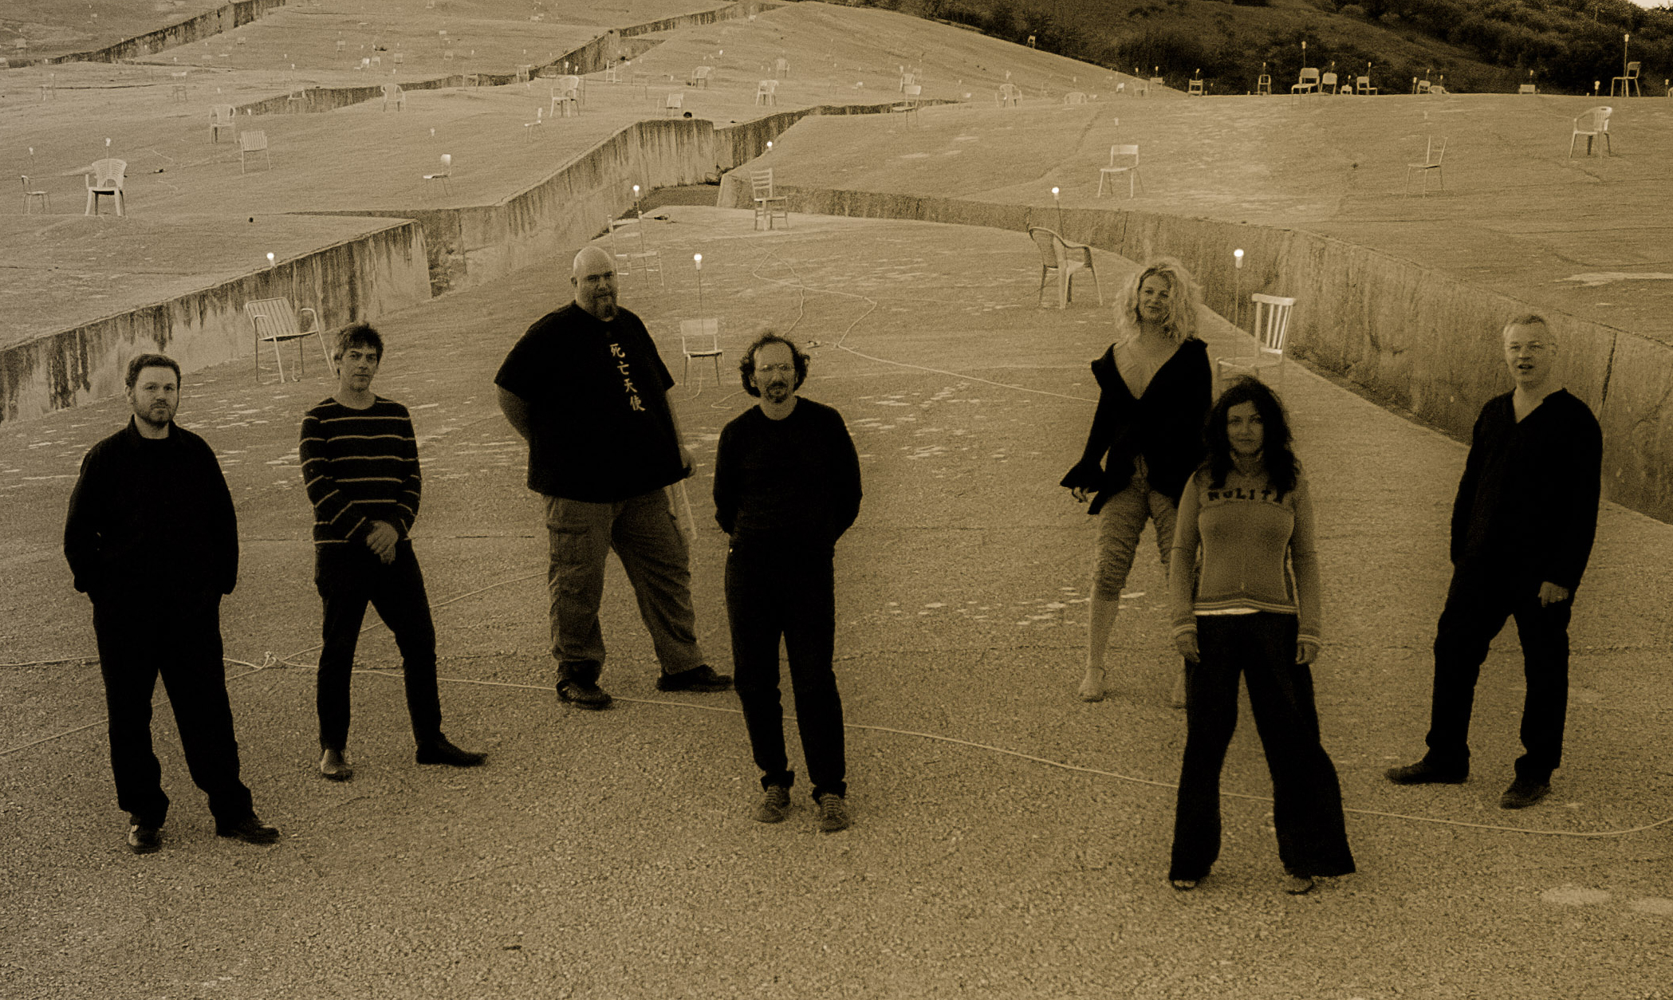

Stefano Saletti and the Piccola Banda Ikona

The voice of the Mediterranean

The show:
A fascinating journey between the sounds and cultures of the Mediterranean sea in the research for a musical and lyrical language that unites its various populations. This is the idea behind the show of Stefano Saletti and the Piccola Banda Ikona A journey to rediscover the different types of music that tell the stories about the passion of the Mediterranean people.

Watch the video of “Piazza Tahrir” (live): http://www.youtube.com/watch?v=K56uwzRrgM8&list=PLCAE71AE1DD60BF85

Watch the video of “El Ejercito del Ebro” (live):
http://www.youtube.com/watch?v=2SYowbsK0i4&list=PLCAE71AE1DD60BF85

Watch the video clip of “Hija mia mi querida”:
http://www.youtube.com/watch?feature=player_embedded&v=zfXKtAp6K6Y

The Biography:
A multi-instrumentalist, expert in Mediterranean music and director of international ensembles, Stefano Saletti is the founder of the Piccola Banda Ikona, comprised of such famous musicians such as the vocalist Barbara Eramo the violinist Carlo Cossu, the bassist Mario Rivera, the winds player Gabriele Coen and the drummer Giovanni Lo Cascio.
Many of the Piccola Banda Ikona's original compositions are sung in Sabir, a lingua franca used by sailors, pirates, fishermen, merchants and ship-owners in Mediterranean ports to communicate with one another: from Genoa to Tangiers, from Salonika to Istanbul, from Marseilles to Algiers, from Valencia to Palermo, until the early decades of the twentieth century this form of sea-faring “Esperanto” developed little by little availing of terms from Spanish, Italian, French and Arabic.

In their last cd "Soundcity: sounds from border towns"(published by Finisterre and distributed by Felmay) Stefano Saletti started from the recordings that, in the past few years, he had made around the Mediterranean in many border cities: Lampedusa, Istanbul, Tangier, Lisbon, Jaffa, Sarajevo, Ventotene... Sounds, noises, radios, voices, sound spaces, buskers have all inspired his melodies, lyrics and rhythms.

Their previous cd called "Folkpolitik" contains Saletti’s original compositions and arrangements of tunes by the Mediterranean authors who, through their music, have described the struggle against power, suffering, persecution, arrests and violence
In October 2012 “Folkpolitik” has reached the top ten of World Music Charts Europe and remained on the charts for three months.

The cd "Marea cu Sarea" (out in 2008) was listed among the ten best new issues on the Folk Roots chart, the prestigious English world music magazine, in addition to being listed as one of the best releases of 2008 by the World Music Charts Europe.
"Marea cu Sarea" was awarded the “Coups de coeur du jury” award at Babel Med 2009 in Marseilles.

In recent years Stefano Saletti and the Piccola Banda Ikona have toured extensively, playing at major international festival in Italy, Portugal, Spain, France, Bosnia-Herzegovina, Morocco, Hungary, Greece, Egypt and Germany.
Their first album "Stari Most", issued in 2005, was dedicated to the historical bridge in Mostar (Bosnia), bombed in 1993, and which has always represented a symbol of the meeting and passage between East and West
Stefano Saletti and the Piccola Banda Ikona boast numerous collaborations with writers and theatre directors in national and international tours.

LINE UP:
Stefano Saletti: bouzuki, oud, guitar, vocals
Barbara Eramo: vocals
Carlo Cossu: violin
Gabriele Coen: sax and clarinet
Mario Rivera: acoustic bass
Giovanni Lo Cascio: drums and percussion

Contacts:
info@piccolabandaikona.it

web:
www.piccolabandaikona.it
www.finisterre.it
www.felmay.it
press office:
Fabiana Manuelli: fabianamanuelli@gmail.com

